**Perancangan Sistem Pengukuran Dengan Sensor Interfacing Voltage Dan ACS712 Untuk Solar Photovoltaic Analysis**

**Rancang Bangun Sistem Monitoring Daya pada Solar Photovoltaic berbasis IoT**

*Measuring System Design with Interfacing Voltage and ACS712 Sensor*

*for Solar Photovoltaic Analysis*

**James Julian**[1]**\*, Ade Fikri Fauzi2 Annastya Bagas Dewantara3**

1Universitas Pembangunan Nasional Veteran Jakarta, Jl. RS. Fatmawati Raya, Pd. Labu, Cilandak, Jakarta Selatan, Indonesia

2Institusion, Institution Address, country of author (Trebuchet MS 8 pt)

|  |  |  |
| --- | --- | --- |
| **Article information**  Received:  xx/xx/xxxx  Revised:  xx/xx/xxxx  Accepted:  xx/xx/xxxx |  | ***Abstract***  ***Research related to developing renewable energy sources are directed at developing the conversion of solar energy into electricity by utilizing solar panels. The power on the panel varies depending on changes in the intensity of solar radiation and the temperature of the panel, with different results for different times of the day depending on environmental parameters. Users can monitoring energy usage and consumption from the electrical loads by observing the real-time data. The research carried out later aims to design supporting measurement devices in the solar PV analysis process using an ATmega2560-based data logger with ACS712 voltage sensors and current sensors. Before entering the measurement and analysis stage, a calibration process must be carried out first using linear regression by applying the Fixed calibration method. Linear regression can be used to predict later values ​​through comparisons made in calibration. The research method used is a quantitative research method with the quantitative data used is the analog sensor reading data and numerical analysis by interpolating and analyzing the dependant variable. Based on the research that has been done, it can be concluded that the voltage has increased and has good stability on sunny day conditions with a stable range of voltage, current, and power in the time range 08.30 - 14.00 with an average of 8.9268 Watts. The results of the comparison of the measurement process get an error value from the voltage sensor measurement ranging from 0.42 to 1.01 percent with a standard deviation of 0.02 to 0.12.***  ***Keywords: Solar Panel, data logger, voltage sensor, current sensor.*** |
|  |  |  |
|  |  | **Abstrak**  Penelitian terkait pengembangan sumber energi terbarukan diarahkan pada pengembangan konversi energi surya menjadi energi listrik dengan memanfaatkan panel surya. Daya pada panel bervariasi tergantung pada perubahan intensitas radiasi matahari dan suhu panel, dengan hasil yang berbeda untuk waktu yang berbeda dalam sehari tergantung pada parameter lingkungan. Pengguna dapat memantau penggunaan dan konsumsi energi dari beban listrik dengan mengamati data secara real-time. Penelitian yang dilakukan nantinya bertujuan untuk merancang alat ukur pendukung dalam proses analisis solar PV menggunakan data logger berbasis ATmega2560 dengan sensor tegangan ACS712 dan sensor arus. Sebelum memasuki tahap pengukuran dan analisis, harus dilakukan proses kalibrasi terlebih dahulu menggunakan regresi linier dengan menerapkan metode kalibrasi tetap. Regresi linier dapat digunakan untuk memprediksi nilai selanjutnya melalui perbandingan yang dibuat dalam kalibrasi. Metode penelitian yang digunakan adalah metode penelitian kuantitatif dengan data kuantitatif yang digunakan adalah data pembacaan sensor analog dan analisis numerik dengan interpolasi dan analisis variabel dependen. Berdasarkan penelitian yang telah dilakukan, dapat disimpulkan bahwa tegangan mengalami peningkatan dan memiliki stabilitas yang baik pada kondisi hari cerah dengan rentang tegangan, arus, dan daya yang stabil pada rentang waktu 08.30 – 14.00 dengan rata-rata 8.9268 Watt. . Hasil perbandingan proses pengukuran mendapatkan nilai error dari pengukuran sensor tegangan berkisar antara 0,42 hingga 1,01 persen dengan standar deviasi 0,02 hingga 0,12.  **Kata Kunci:** Solar Panel, data logger, sensor tegangan, sensor arus. |
|  |  |  |

1. **INTRODUCTION**

At the end of the 20th-century world scientists focused their efforts on the development and application of energy production technologies called "renewable energy". This decade began to see an increase in massive-scale energy utilization by utilizing the use of solar energy (Meyer, 2017; Yordanov, Hadzhidimov and Zlateva, 2021). The benefits of clean or renewable energy are getting higher as the use of conventional energy resources, such as oil, natural gas, and coal, is reduced (Eteruddin *et al.*, 2019). The government also wants to build public awareness of protecting the environment from the effects of carbon emissions. One of the efforts related to the development of renewable energy sources is directed at developing the conversion of solar energy into electricity, by utilizing solar photovoltaic (PV) panels or commonly called solar panels. (Takyi and Nyarko, 2020). Reported on the ESDM West Java website, in December 2021 Indonesia's solar PV power plants will reach 48.79 Megawatts. The solar power plant program is one of the PSN (Proyek Strategis Nasional). The government regulates special regulations through Minister of Energy and Mineral Resources Regulation No. 26 of 2021 concerning Rooftop PLTS, where the policy encourages the growth of domestic PLTS supporting industries and increases competitiveness by increasing the Level of Domestic Components (TKDN) related to work companies. Dalam proses merancang sistem PV, sangat penting bahwa panel kontrol memastikan pengiriman daya maksimum dengan Pelacakan Titik Daya Maksimum (MPPT) (Cotfas, Cotfas and Machidon, 2018). The power in the solar PV module depends on changes in solar radiation intensity and panel temperature, different power results for different times can occur (Eteruddin *et al.*, 2019) it was explained that the increase in temperature affected the output of the module, the voltage decreased by 1.435 volts (4.1%) /ºC with constant sunlight intensity, on a 150 Wp solar panel. Furthermore, when the solar PV is connected by the load there is a significant change, where the voltage drops to 15,395 volts. The decrease in addition to the effect of temperature is also influenced by the ideal factor of the solar PV module, in (Meyer, 2017) is describe with Vmp dan Imp can be determined the graph of the ideal factor of the module. The voltage drop can be affected by the load used on the solar PV module. The input to the load must be adjusted again, due to the difference given. Implementation of MPPT requires various methods, with adjustments Vmp and Imp each method has a different level of complexity depending on the desired result. By carrying out simple interference and monitoring, information will be obtained regarding the installation of solar panels to produce the desired output power. If solar panel output data can be obtained in real time in graphical form, then solar panel power users can manage energy consumption and electricity loads. When running at maximum value, the device can lose significant energy due to incomplete MPP tracking. Some methods require an initial step to avoid the circuit reaching proximity to the MPP. So, adjusting the data on the voltage and current sensors to the solar PV input power is important for setting MPP circuit limits (Yordanov, Hadzhidimov and Zlateva, 2021).

The research conducted aims to design supporting measurement devices in the solar PV analysis process. By calibrating the voltage and current sensors, then compensating for Vmp and Imp in the process of using the device for further operation or charging. The measurement system is designed and structured using the ATmega2560 with the Arduino Mega Pro microcontroller as the processing base. The preparation is done by wireless transmission which records data on a local server, then a memory card module is installed as a backup storage medium.

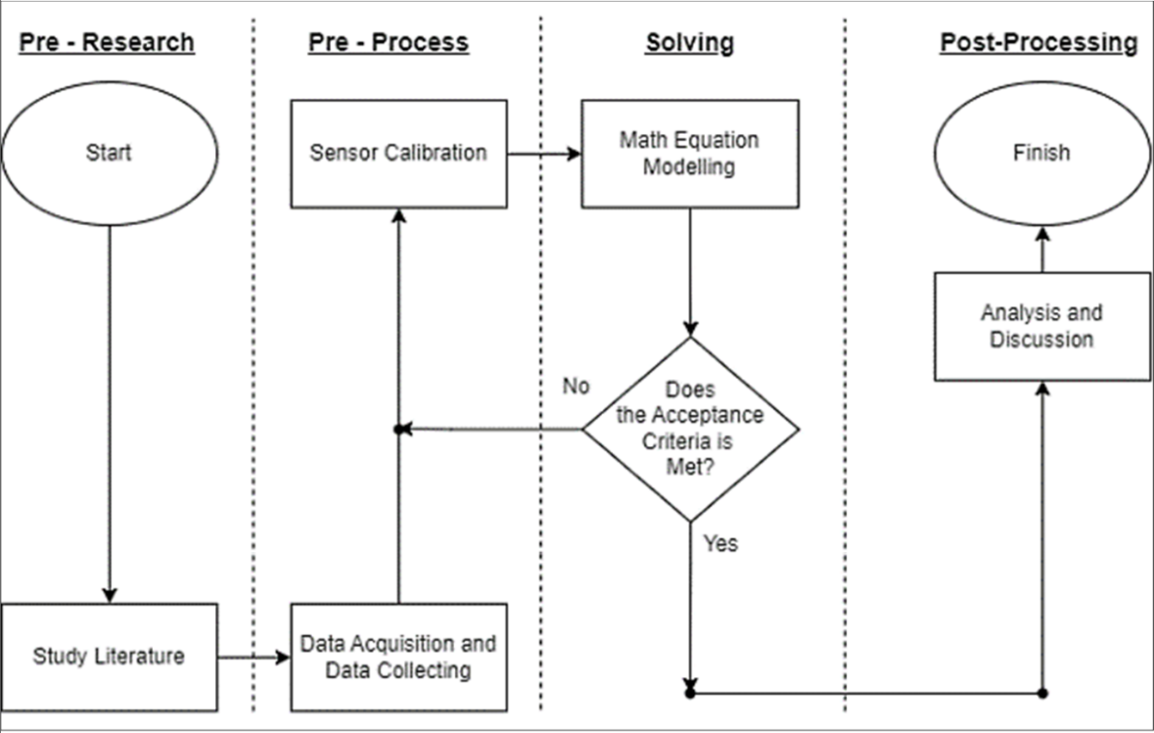

**Figure 1.** Research Method Diagram

1. **METHODOLOGY**

Maximum Power Point Tracking (MPPT) is the maximum output power point at a certain light intensity level. MPPT requires sensing the relevant supply conditions and setting current limits accordingly (Calabrò, 2013; Masili and Ventura, 2019). Clustering is done by a mechanism where models are collected into two types. Cluster selection is done based on each variable. Various models have been developed as a function of measurement as a unit in input management (Naihong *et al.*, 2006). Solar PV behaves as a voltage limited current source (as opposed to a battery which is a fixed voltage source) (Yordanov, Hadzhidimov and Zlateva, 2021). Its use has MPPT where the ratio of power extracted from the panel must be maximized. Finally, when the amount of incident solar radiation decreases, the value Isc also reduced. Due to its characteristics, it is difficult to power the target system directly from the solar panels, as the supply voltage depends on the load impedance which varies with time (Takyi and Nyarko, 2020). Therefore, charging media and energy storage, are needed to store energy from solar PV, then used to provide a stable voltage to the system.

1. **Solar Photovoltaic Module**

The photon charge in solar radiation affects the work on solar PV, the composition of the light is absorbed by the semiconductor material. This physical phenomenon is formed from light energy that comes then hits the surface of the solar PV and turns into electrical energy. This reaction is the photovoltaic effect, with power that can be generated using the sun's energy charge (Masili and Ventura, 2019). Electricity in the module can arise because the photon charge in the incident light frees the electrons in the N-type (negative) and P-type (positive) semiconductor junctions. Electrons (negatively charged particles) are energized and flow through the semiconductor material to generate electricity. Electrons are only allowed to move in one direction due to the emptying region. The electrons in the conduction band from the N region spread out to the P region where there are many holes which cause the electrons to combine and fill the holes. The previous holes and existing free electrons vanish, leaving positively charged donors on the N-side and negatively charged acceptors on the P-side. Complementary positive charge flows in the opposite direction to the electrons in a silicon solar panel (Naihong *et al.*, 2006).

Solar PV silicon crystals are divided into cells made of polycrystalline or monocrystalline. The cell efficiency for mono-crystalline silicon was found to be higher than for poly-crystalline silicon (Zaini *et al.*, 2015). Then monocrystalline was chosen to be the test module on the device. The standard test condition (STC) for solar cell performance is the solar radiation spectrum called an Air Mass 1,5, radiation 1000 W/m2, and temperature of the cell describe as 25 °C.

**Table 1.** Caracteristic Solar PV’s Module Mono-Cristalline 50 Wp (Zaini *et al.*, 2015)

|  |  |  |
| --- | --- | --- |
| **Parameter** | **Variable** | **Value** |
| Rated power | Pm | 18.68 V |
| Voltage at maximum power | Vmp | 2.77 A |
| Current at maximum power | Imp | 2.77 A |
| Open-circuit voltage | Voc | 22.53 V |
| Open-circuit voltage | Voc | 22.53 V |

The application of solar PV must also be regulated regarding the angle of inclination and facing direction based on the cardinal points. In an environment that has a position in the northern region, of course solar PV must be positioned facing south, adjusting the equator to the direction of the sun's circulation (Masili and Ventura, 2019). The Depok, West Java area have a pattern Optimum tilt of PV modules 10/0º, Solar Azimuth 0º - North, Global tilted irradiation at optimum angle 4.605 kWh/m2 per day, Air temperature 26.9 ºC.

1. **Electrical Circuit**

The components used in making the measurement system as a solar PV analysis device later. Before entering the measurement and analysis phase, a calibration process must be carried out first. The machine goes through the process of adjusting the accuracy of the measuring instrument by comparing it with following the standards/benchmarks of other devices or based on standard standards (Wishnu Pandu Prayudha, Fadhil and Novianto, 2022). In his writings (Huriaty, 2015) Explained that there are three ways of calibration, namely separate calibration, concurrent calibration, and fixed calibration. (1) A separate calibration method is carried out where the item parameters in each test are estimated separately or individually to obtain a general scale deferred on one scale, namely the scale (0.1), then other scales originating from separate calibrations must be completed first to the basic scale. (2) The concurrent calibration method is the process of estimating parameters for all items and for all tests in one estimation process and placing all parameter estimates on the same scale, namely (0.1) or on a general scale. When concurrent calibrations are performed, it is important to use an estimation program that allows you to calibrate several batches concurrently. (3) Fixed calibration method, where calibration produces a standard scale by setting common item parameters and then estimating the standard item parameters and non-shared items to place them on the same scale. There are two fixed calibration methods, namely the fixed C method and the fixed ABC method. In fixed C, the estimated parameter c from the reference test is used as the initial value for the target test, and both are no longer estimated, while parameters a and b are estimated. After item parameter estimation, the process for finding the A and B values ​​used in the linear transformation is the same as for the separate calibration method.

The sensor calibration process uses linear regression by applying the Fixed Calibration method. Linear regression can be used to predict later values ​​through comparisons made in calibration. The path with the function of the regression analysis where valid results can be used for forecasting and prediction of values. The process is carried out by placing variable parameter c as a digital multimeter measurement which is then compared with the analog sensor response value.

$y=β_{0}+β_{1}.x+ε$ (1)

Dimana,

y = dependent variable (analog read)

x = independent variable (voltage/current on multimeter)

𝛽0 = constant or intercept variable (a)

𝛽1 = x slope coefficient (b)

$ε$ = error term

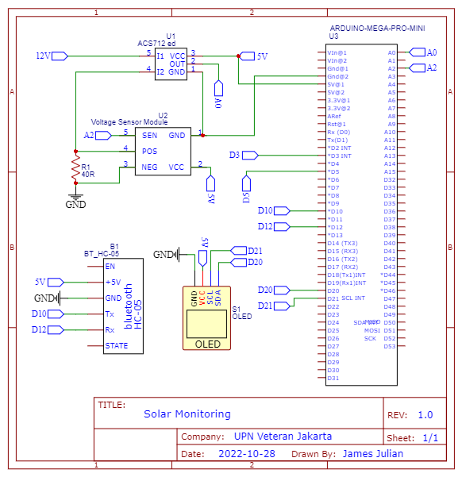

**Figure 2.** Scematic Measurement Circuit Design

After getting the two variables together, values ​​are entered with an approximate linear increment to get the average increment variation from the analog sensor.

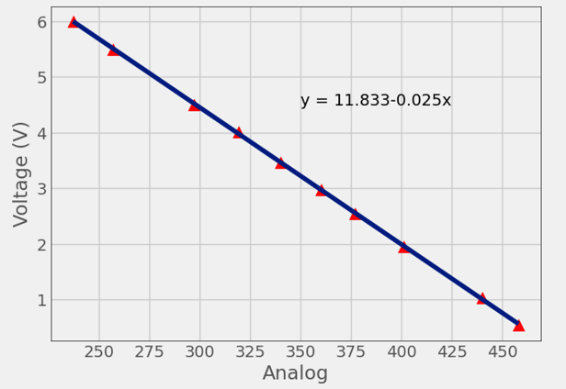

(a)

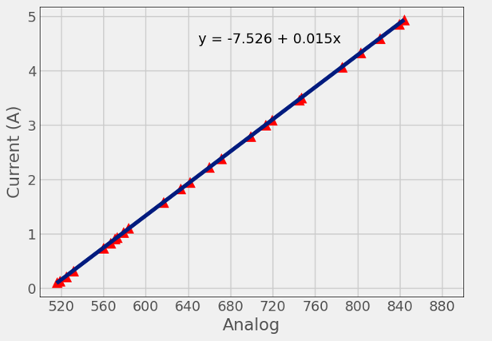

(b)

**Figure 2.** (a) Linear Regression Result for Voltage Sensor, (b) Linear Regression Result for Current Sensor

The schematic shown in figure 1, the calibration device consists of the following elements: Voltage Regulator (supply), Potentiometer, Interfacing Voltage Sensor, ACS712 (Current Sensor), Arduino Mega Pro, Adjustable Load. The process of calibrating starts from adjusting the input voltage and current on the sensor, then the analog sensor value is aligned with the value on the digital multimeter. The settings for the linear regression function are done using the running function. So the user only needs to fill in the required variables, the more samples taken, the better the accuracy of the data obtained (Fachri, Sara and Away, 2015).

The work of the interfacing voltage sensor in a simple way is to divide the voltage from the input into a voltage divider circuit of two resistors where R1 is 30K Ohm and R2 is 7.5K Ohm. The voltage range that can be measured by the module is between 0.02445 to 25 volts. As it is known that the measurement of the voltage value is carried out by connecting the measuring device in parallel with the voltage source. Then the voltage is divided into smaller units and converted into an analog signal (Suryawinata, Purwanti and Sunardiyo, 2017). Comparison of the actual voltage that is converted to an analog signal.

Then the use of the ACS712 sensor is carried out by connecting the solar panel power input in series to the load. The device utilizes the intensity of the magnetic field signal to the transducer provided by the BiCMOS Hall IC with low offset. The current flowing through the primary copper conduction path (from pins 1 and 2, to pins 3 and 4) is used as current sensing. To read the zero Ampere value, the sensor voltage is set to 2.5V, which is half the VCC 5V power source voltage and the analog value read is around 511 on the Arduino Mega A0 analog pin. The sensor can withstand a wide range of temperatures -40 to 85**º**C with the sensitivity range around +100mA. The current measurement range 0.1 to 20 A (Rusman, 2015). The current signal that causes the hall effect process is packed into an analog signal.

After all the preparations were completed, the comparison process began. Devices that have good accuracy are needed with data processing in searching for standard deviation parameters, precision and increased accuracy (Magaski and Anwari, 2022). To seek precision, the concept of uncertainty is approached. Precision derived from repeated measurement methods is impossible to express precisely using the concept of error. In his writings, (Vurchio *et al.*, 2020). The most possible precision quantification is using the concept of uncertainty. The uncertainty originating from the precision of the method is the Standard Deviation (SD) value of the sample test used, carried out at least in duplo (3 repetitions). Using the CL (Confident Level) theory, the coverage probability obtained in the first approach changes the nominal uncertainty interval. The confidence level used in general is 95%, the treatment where the confidence level is 95% (the sample value will represent the value of the population where the sample variation originates). Then the level of feasibility for the new device can be ascertained by the results obtained. The process of taking variations from variables is carried out simultaneously with field data collection as a form of direct comparison. The calculation of the differentiation formation process is realized by the equation: $Ev[R]=μ$

$σ=\sqrt{Ev[{(R-μ)}^{2}]}$ (2)

$σ=\sqrt{Ev{[R]}^{2}+Ev\left[\left(-2μR\right)\right]+Ev[μ^{2}]}$ (3) $σ=\sqrt{Ev{[R]}^{2}-2μEv[R]μ^{2}}$ (4) $σ=\sqrt{Ev{[R]}^{2}-{(Ev[R])}^{2}}$ (5)

dimana,

$σ$ = standard deviation

$Ev$ = average value of R

$R$ = random variable

$μ$ = mean value

1. **Data Processing**

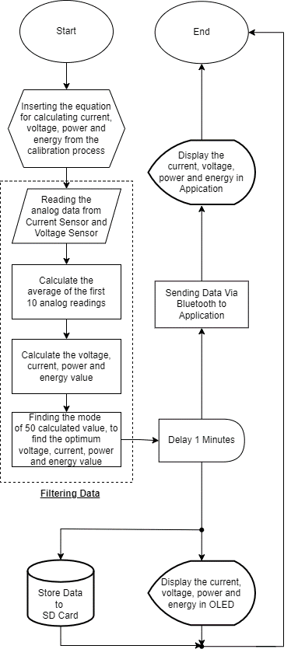

**Figure 3.** Device Algorithm Flow Chart

Measurements were made on the solar PV module by entering the formula calculation results equation from the calibration of analog data measurements. Then the data is compared with the results of direct measurements of the voltage value and current value on a digital multimeter.

Analog data that is read from the sensor is processed into the filtering stage to reduce variations and fluctuations in the readings that occur. The filtering process is divided into two phases. The first filtering is done by finding the average value of the first 10 analog data values ​​that are read from the current and voltage sensors. The data that has been filtered from the voltage value is entered into the equation of the calculated formula in the calibration process. Interpolation is carried out to calculate each value of the voltage, current, power and energy produced. The calculated data is filtered again by looking for the terms of the value that appear most often or looking for the mode value of the first 50 data sets that have been read in an effort to increase precision and accuracy in the reading process.

1. **RESULTS AND DISCUSSION**

The data collection process in this study was carried out using a device connected to the Bluetooth sensor HC-SR05 device as a medium for sending realtime data from the sensor. Then the comparative calculation value is given to get the error variation (Error) from the device reading. After that the level of uncertainty on the sensor is determined, as a form of device confidence in a universal measuring instrument or actual measuring equipment.

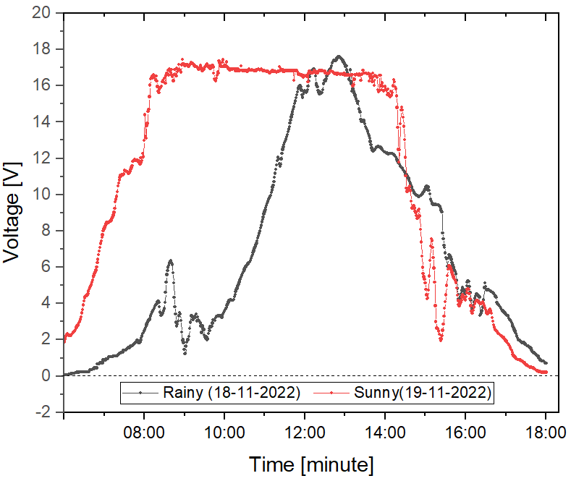

(a)

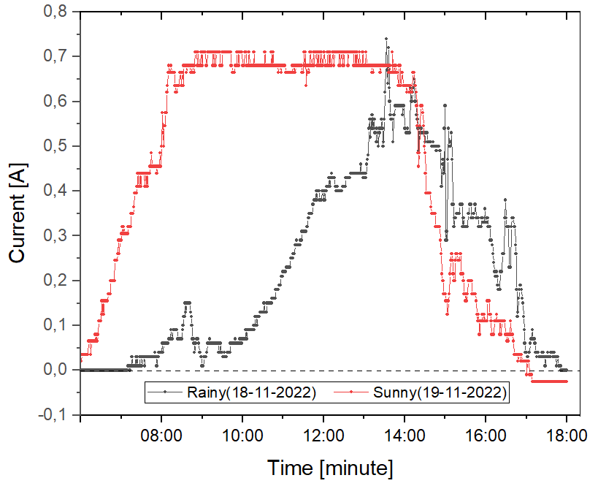

(b)

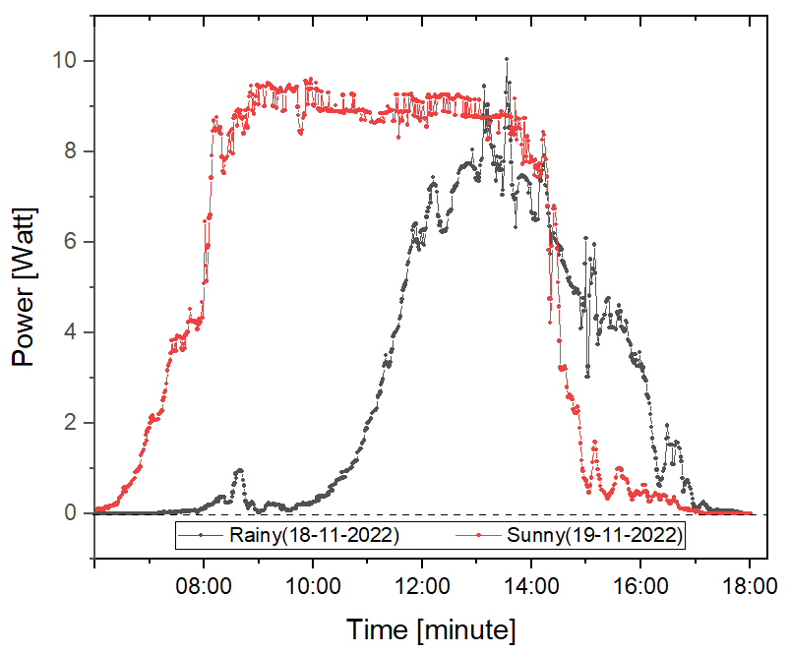

(c)

**Figure 6.** (a)Voltage, (b)Current, (c)Power, Device Measurement For Rainy and Sunny Days

The measurement data on the device shows that the increase and stability of the voltage tend to be better on sunny day conditions. The solar PV module starts to generate voltage at 06:00 where the process is faster than on a rainy day. The bullish pattern that is formed also moves faster. At 14:00, Sunny day experienced a decrease process which was disrupted due to changes in light intensity due to the presence of cloudy clouds. The range of voltage, current and power is stable at 08:30-14:00 with an average of 8.9268 Watts. The highest power is at 9.5942 Watt. In the later comparison, the variable used is sunny day with constant variation and intensity. Because the work of the solar PV module is not disturbed, ideal conditions can be measured through measuring devices and instruments.

**Table 2.** Result Interface Voltage Sensors Measurement Through the Device and Digital Multimeter

|  |  |  |  |  |
| --- | --- | --- | --- | --- |
| **Time** | **Device (Vmean)** | **Instrument (V)** | $σ$**(V)** | **Galat (%)** |
| 07:00 | 8,98 | 9,04 | 0,06 | 0,66 |
| 07:30 | 12,45 | 12,54 | 0,09 | 0,71 |
| 08:00 | 14,53 | 14,61 | 0,08 | 0,54 |
| 08:30 | 18,43 | 18,52 | 0,09 | 0,48 |
| 09:00 | 19,24 | 19,34 | 0,1 | 0,51 |
| 09:30 | 19,04 | 19,14 | 0,1 | 0,52 |
| 10:00 | 19,21 | 19,31 | 0,1 | 0,51 |
| 10:30 | 18,87 | 18,96 | 0,09 | 0,47 |
| 11:00 | 18,87 | 18,95 | 0,08 | 0,42 |
| 11:30 | 18,85 | 18,94 | 0,09 | 0,47 |
| 12:00 | 18,55 | 18,64 | 0,09 | 0,48 |
| 12:30 | 18,87 | 18,99 | 0,12 | 0,63 |
| 13:00 | 18,63 | 18,71 | 0,08 | 0,42 |
| 13:30 | 18,73 | 18,83 | 0,1 | 0,53 |
| 14:00 | 17,9 | 17,98 | 0,08 | 0,44 |
| 14:30 | 13,45 | 13,52 | 0,07 | 0,51 |
| 15:00 | 5,59 | 5,63 | 0,04 | 0,71 |
| 15:30 | 4,42 | 4,46 | 0,04 | 0,89 |
| 16:00 | 4,54 | 4,58 | 0,04 | 0,87 |
| 16:30 | 3,91 | 3,95 | 0,04 | 1,01 |
| 17:00 | 2 | 2,02 | 0,02 | 0,99 |

The result of the comparison of the measurement process is to obtain the error value from the voltage sensor measurement. The amount of error that occurs in the measurement ranges from 0.42 to 1.01 percent with a standard deviation of 0.02 to 0.12 volts.

**Table 3.** Result ACS712 Sensors Measurement Through the Device and Digital Multimeter

|  |  |  |  |  |
| --- | --- | --- | --- | --- |
| **Time** | **Device (Vmean)** | **Instrument (V)** | $σ$**(V)** | **Galat (%)** |
| 07:00 | 8,98 | 9,04 | 0,06 | 0,66 |
| 07:30 | 12,45 | 12,54 | 0,09 | 0,71 |
| 08:00 | 14,53 | 14,61 | 0,08 | 0,54 |
| 08:30 | 18,43 | 18,52 | 0,09 | 0,48 |
| 09:00 | 19,24 | 19,34 | 0,1 | 0,51 |
| 09:30 | 19,04 | 19,14 | 0,1 | 0,52 |
| 10:00 | 19,21 | 19,31 | 0,1 | 0,51 |
| 10:30 | 18,87 | 18,96 | 0,09 | 0,47 |
| 11:00 | 18,87 | 18,95 | 0,08 | 0,42 |
| 11:30 | 18,85 | 18,94 | 0,09 | 0,47 |
| 12:00 | 18,55 | 18,64 | 0,09 | 0,48 |
| 12:30 | 18,87 | 18,99 | 0,12 | 0,63 |
| 13:00 | 18,63 | 18,71 | 0,08 | 0,42 |
| 13:30 | 18,73 | 18,83 | 0,1 | 0,53 |
| 14:00 | 17,9 | 17,98 | 0,08 | 0,44 |
| 14:30 | 13,45 | 13,52 | 0,07 | 0,51 |
| 15:00 | 5,59 | 5,63 | 0,04 | 0,71 |
| 15:30 | 4,42 | 4,46 | 0,04 | 0,89 |
| 16:00 | 4,54 | 4,58 | 0,04 | 0,87 |
| 16:30 | 3,91 | 3,95 | 0,04 | 1,01 |
| 17:00 | 2 | 2,02 | 0,02 | 0,99 |

In knowing how accurate the data sample is in measuring the sensor accuracy of a measurement population, a standard error calculation is carried out by varying the voltage level from 0.5 V to 21 V with a sample

of 1000 samples.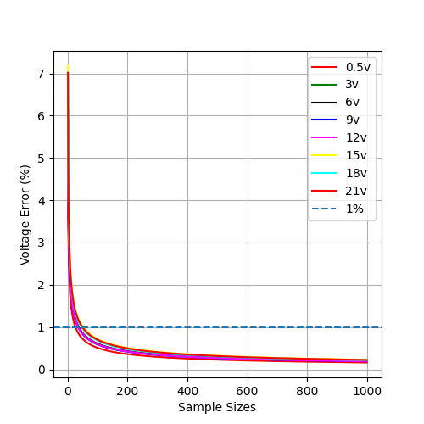

Through calculations, the sample size is obtained when it reaches a standard error value of 1% by varying the voltage value as shown in table below

**Table 3.** The results of the standard error and standard derivation of taking 1000 samples by varying the voltage variable

|  |  |  |
| --- | --- | --- |
| Voltage (V) | Standard  Deviation $$(σ)$$ | N when  SE 1% |
| 0.5 | 0,0509 | 25,990 |
| 3 | 0,0689 | 47,481 |
| 6 | 0,0608 | 37,052 |
| 9 | 0,0589 | 34,697 |
| 12 | 0,0595 | 35,520 |
| 15 | 0,0718 | 51,569 |
| 18 | 0,0684 | 46,888 |
| 21 | 0,0701 | 49,223 |

Error distribution measurements were carried out for each voltage variation, and the average error value was -0.0236275, with the mode and median values -0.01. Using the central tendency method, it is known that the error distribution is a negative skewed distribution.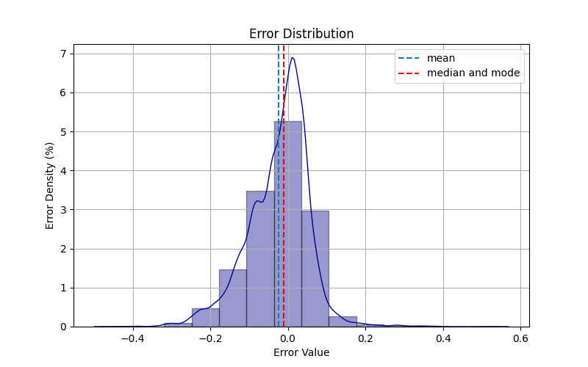

To find out the distribution and variation and to test the differences in each data distribution, graphical visualization was carried out using boxplot charts and analysis using the Analysis of Variance (ANOVA) method. The type of ANOVA used is one-way ANOVA, and the following results are obtained.

**Table 3.** ANOVA result

|  |  |  |  |
| --- | --- | --- | --- |
| DOF  Numerator | F-Stat | P-Value | F-Critical |
| 7 | 579.15 | 0 | 2.6416 |

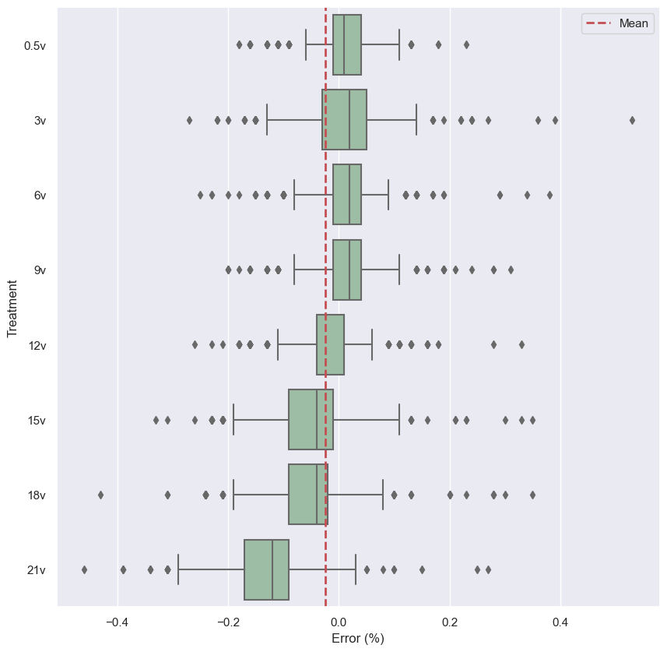

Based on the P-Value of the test, it is known that the test results reject the null hypothesis (H0) and indicate a significant difference between the treatment and accepting the alternate hypothesis (H1) at a significant value of 0.01.

Post Hoc analysis using the Tukey-HSD (Honestly Significant Difference) method was used to identify the differences between the two groups from the differences in the treatment of voltage values.

**Table 4.** Tukey-HSD result

|  |  |  |  |
| --- | --- | --- | --- |
| Voltage | | P-Value | Reject |
| 0.5v | 3v | 0,001548 | True |
| 0.5v | 6v | 0,9 | False |
| 0.5v | 9v | 0,9 | False |
| 0.5v | 12v | 0,001 | True |
| 0.5v | 15v | 0,001 | True |
| 0.5v | 18v | 0,001 | True |
| 0.5v | 21v | 0,001 | True |
| 3v | 6v | 0,001659 | False |
| 3v | 9v | 0,014083 | False |
| 3v | 12v | 0,001 | True |
| 3v | 15v | 0,001 | True |
| 3v | 18v | 0,001 | True |
| 3v | 21v | 0,001 | True |
| 6v | 9v | 0,9 | False |
| 6v | 12v | 0,001 | True |
| 6v | 15v | 0,001 | True |
| 6v | 18v | 0,001 | True |
| 6v | 21v | 0,001 | True |
| 9v | 12v | 0,001 | True |
| 9v | 15v | 0,001 | True |
| 9v | 18v | 0,001 | True |
| 9v | 21v | 0,001 | True |
| 12v | 15v | 0,001 | True |
| 12v | 18v | 0,001 | True |
| 12v | 21v | 0,001 | True |
| 15v | 18v | 0,012038 | False |
| 15v | 21v | 0,001 | True |
| 18v | 21v | 0,001 | True |

Based on the calculation analysis table using Tukey-HSD, we get the difference between the treatment groups between the voltages 0.5v with 6v, 0.5v with 9v, 3v with 6v, 3v with 9v, 6v with 9v, and 15v with 18v. The P-Value with the largest significant value between 0.5V with 6v and 9v is 0.9.

1. **CONCLUSION**

Based on the results of the design, testing, and data collection, the conclusions are as

following :

1. Obtained the value of the equation from the calibration process for the current calculation of

I(x) = -7.526 + 0.015x

V(x) = 11.833 – 0.025x

The value x represents the reading value of 8-bit analog data from the microcontroller.

2. Errors arising from the difference between the voltage and current readings on the microcontroller and the measurement results using a measuring instrument have an average error of 0.6% and 1.91% with a range of 0.13 to 0.73% and 1.15 to 3.25%, which proves that the sensor has good reading quality.

1. * Correspondence Author. Phone: xxx-xxxxxxx ; Handphone xxx-xxxxxxx

   email : xxxxxxx@xxxxxxx.ac.id